**Ahmed Hassan Ismail – BESE-9B – 237897**

**OS Lab 1 Tasks**

Task 1:

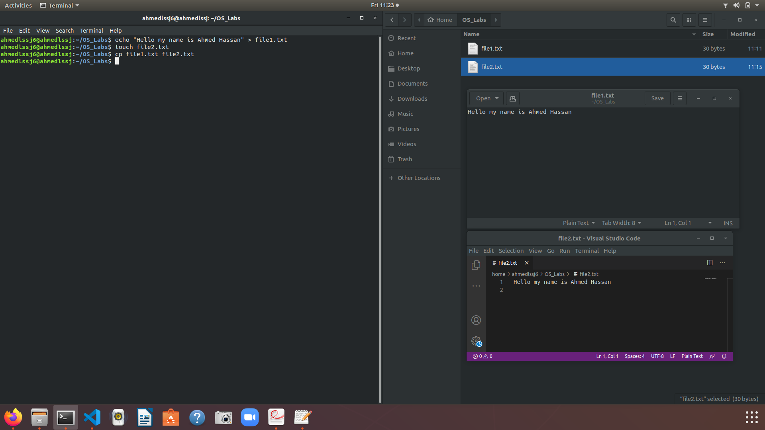

Task2:

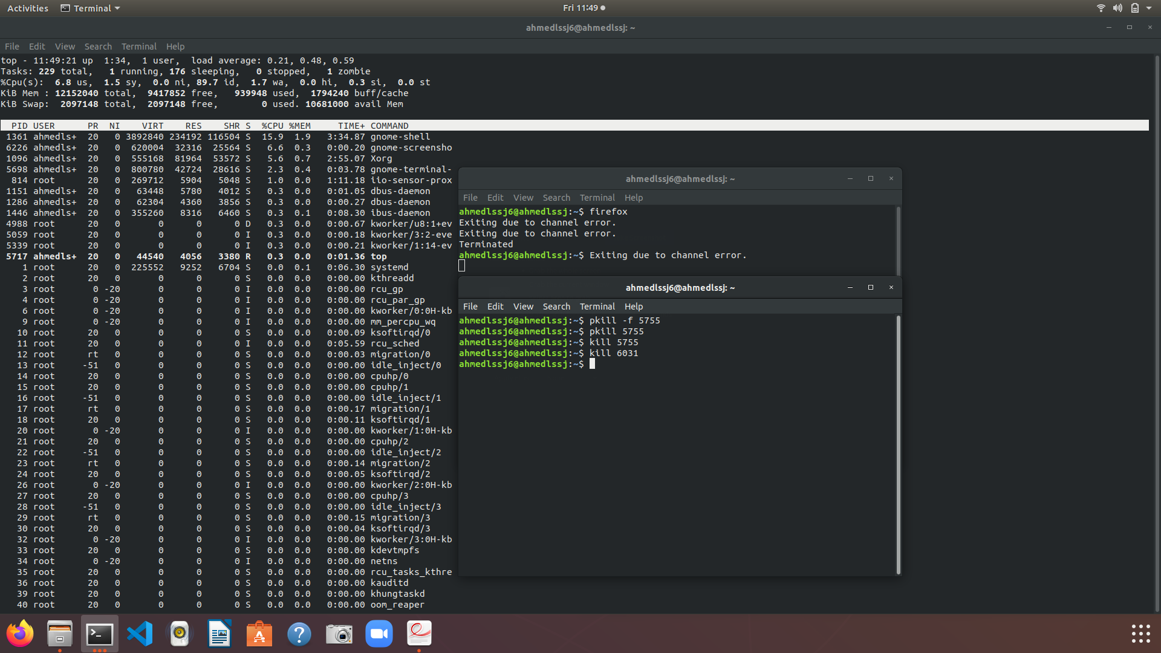

Task 3:

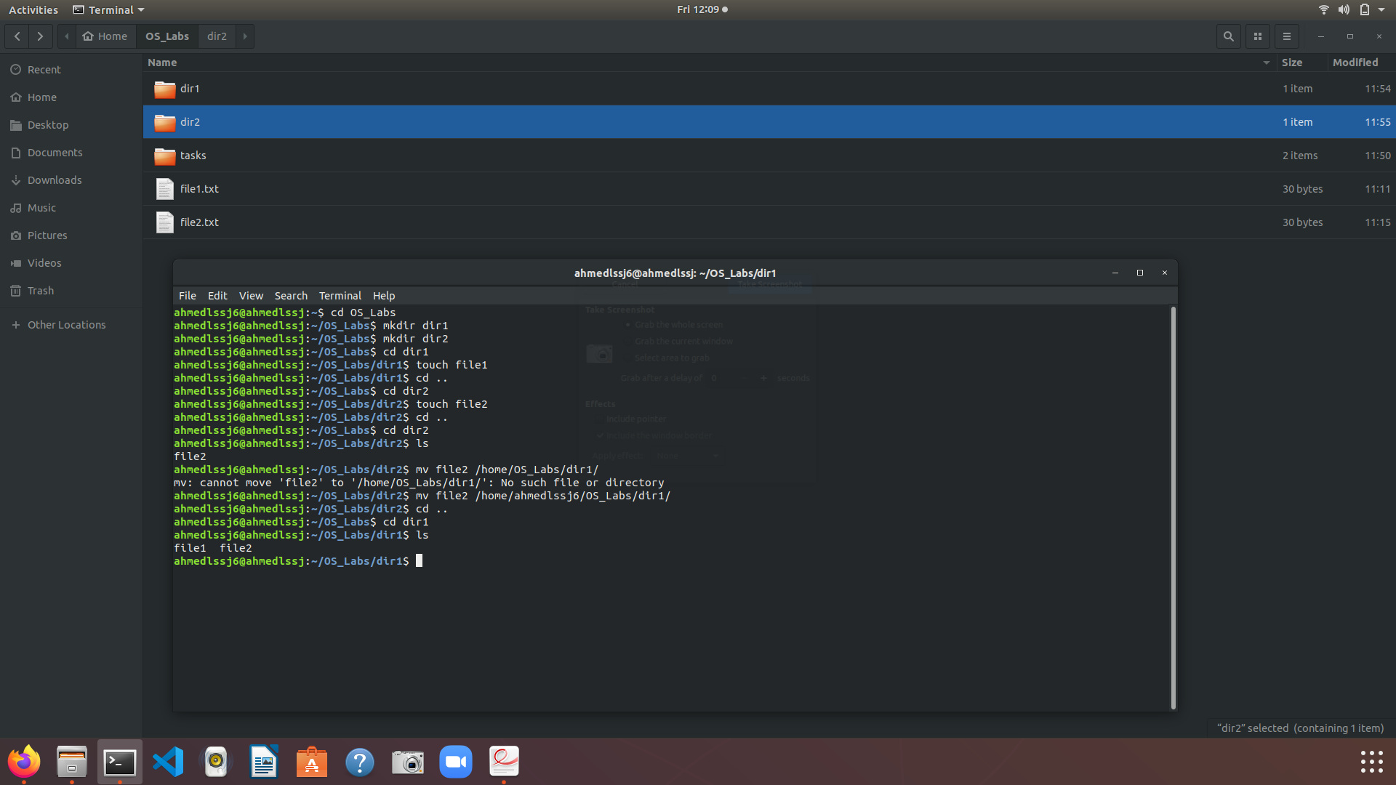

Task 4:

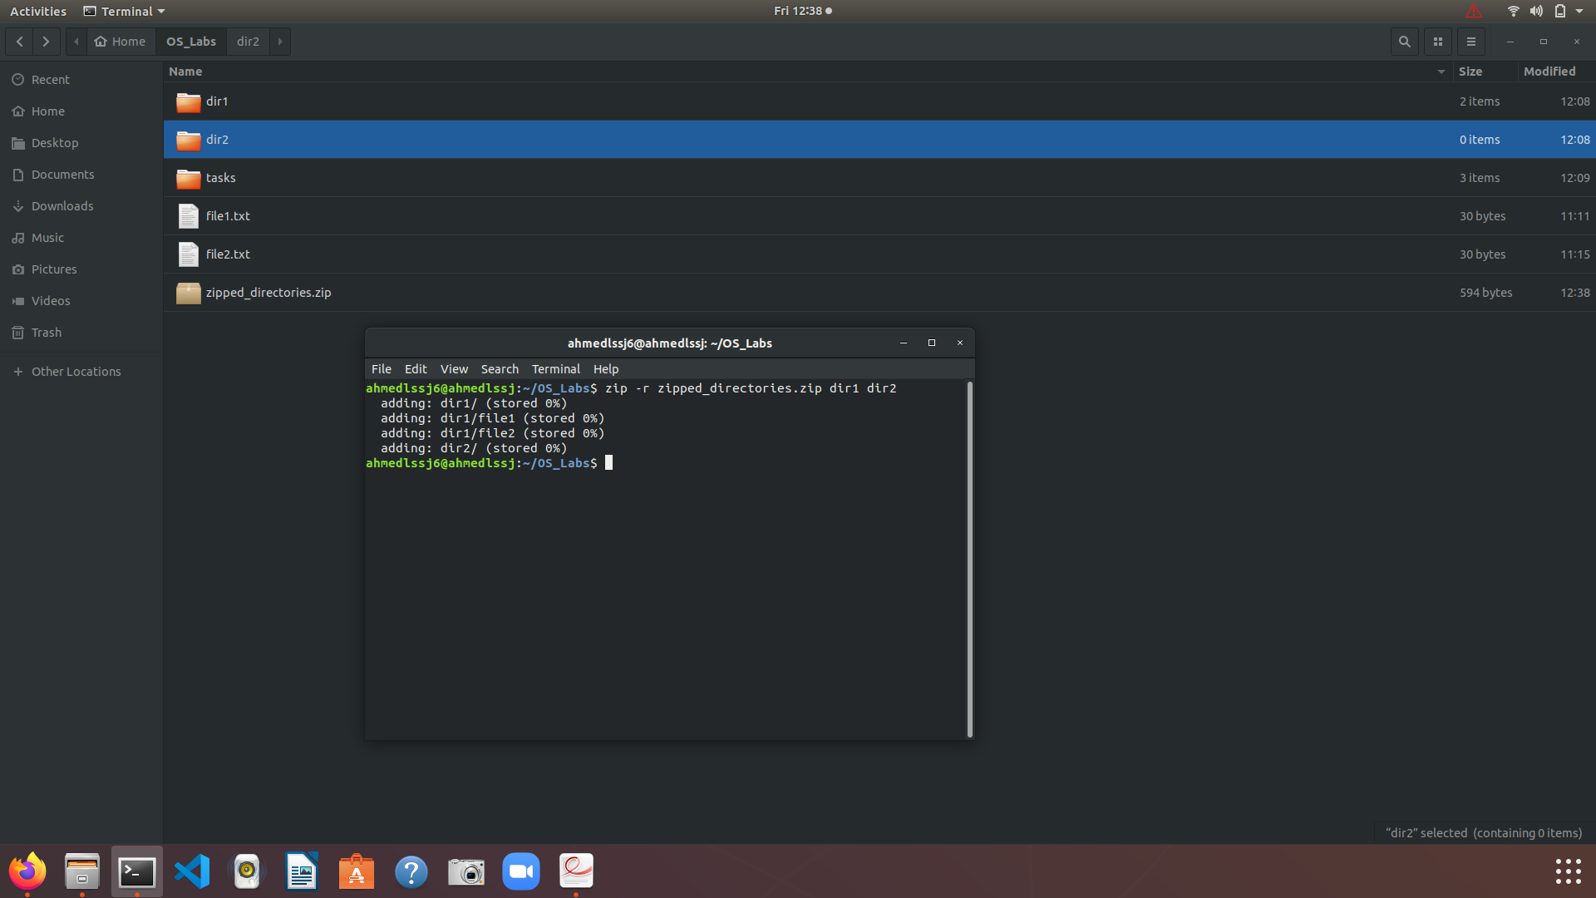

Task 5:

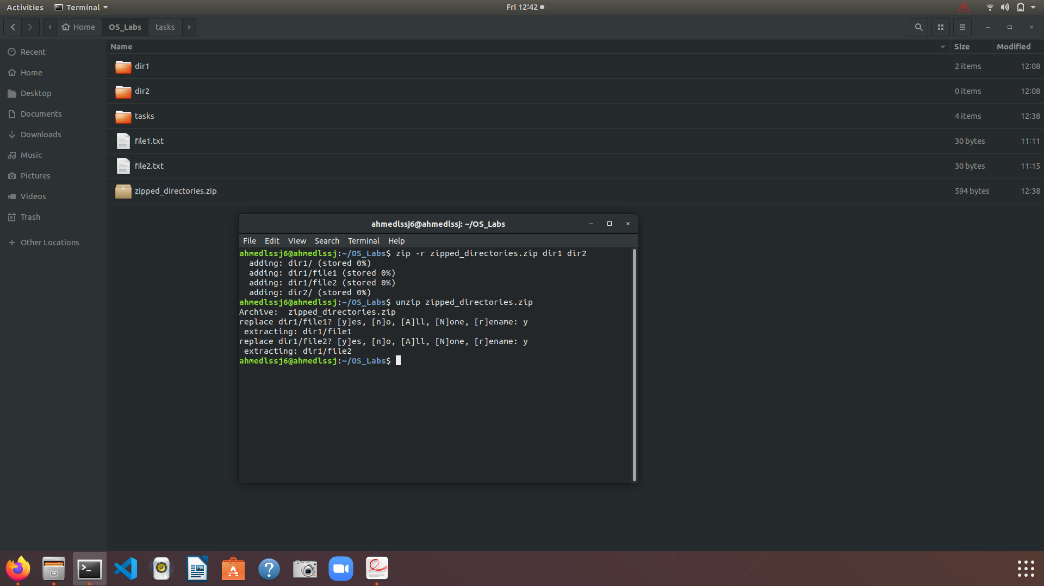

Task 6:

First, we create a file name *.txt then we type “aad(bbb)c c” in that. Afterwards we run the commands.sh file using the ./commands.sh command in the terminal. After the code execution we see that in the newly created *_modified.txt file the parentheses part is erased and the remaining pieces of the string are concatenated.

